# Database issues with Volunteer Management System Pre-Assignment

For the development of our Pre-Assignment the team was required to connect to a database to manage the volunteers associated with the project and to manage the events associated with the centers. The team agreed that I would handle the database as part of his assignment and workload. I conducted research and attempted to use the following database systems.

SQL: SQL was my ideal solution as it is easily put together and I could fill it with test data very simply. The initial concern I had with SQL was not having a Server I could use to host the database. I attempted to use Azure but my account had been disabled between semesters. I do have a local SQL Server running on my desktop but without an online access each team member would have to install their own sql server and then ensure the connection mechanisms were all set up identically.

mySQL: The next solution I attempted was using mySQL, this server required less resources to run and I first attempted to use the server associated with a goDaddy account I own. The goDaddy account wouldn’t allow us to enable outside connections from non-static IP addresses. I then attempted to determine if we could each install our own copies of the mySQL server but ultimately decided we would run into similar issues previously identified with SQL.

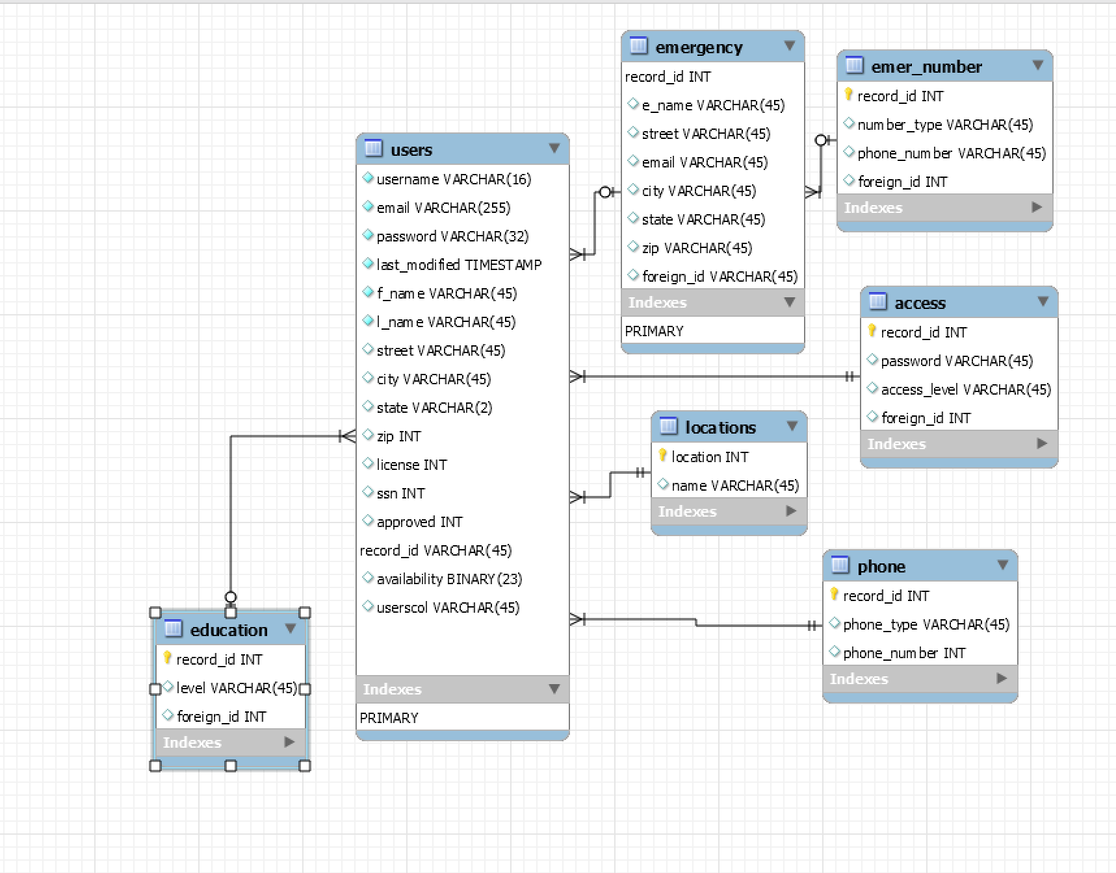

Access MDB: We attempted to connect an access database next. Access would have been ideal because we could self-contain the database in a single file. I conducted research and found that access files could not be connected to Core .net projects.

SQLite: As the development time was drawing to a close I came across SQLite. I started developing the SQLite database and was working on connection strings as I found that this database type was efficient and could be easily utilized for deployment testing. I attempted to develop the database for in memory testing, but was unable to deploy a solution in time for the team to incorporate into the project.